
Richard Bangs’ Adventures with Purpose
Geneva & the Matterhorn: Quest for the Water Castle
Photos and Captions:

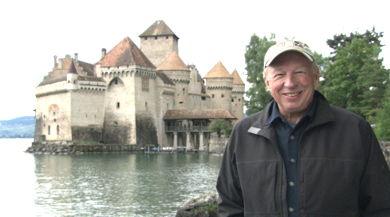
Richard Bangs explores the Geneva and the Matterhorn region of Switzerland on the next edition of Adventures with Purpose. According to Bangs, “Water is over-taxed and under-tended in many places around the world, but not in Switzerland.” So Bangs is on a quest to discover how this alpine haven has resisted temptation to bleed its most precious resource. His travels take him along Lake Geneva with stops in Geneva, Lausanne, Nyon and Vevey. Then he climbs through the Rhone River Valley to the wellspring of the great river high in the pristine peaks of the Uri Alps. . Richard Bangs’ Adventures with Purpose: Geneva & the Matterhorn—Quest for the Water Castle is co-produced by Small World Productions, KCTS/ Seattle and Richard Bangs Productions of Marina del Rey, California. The doc is distributed nationally by APT Exchange.

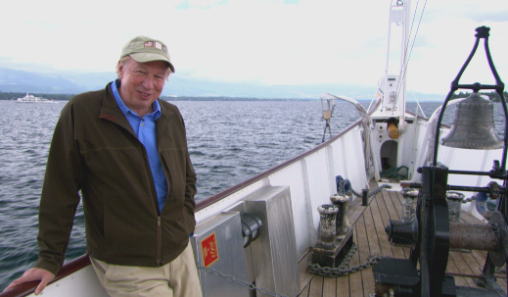
Adventures with Purpose: Geneva & the Matterhorn—Renowned adventurer and award-winning travel writer Richard Bangs boards the Savoie, a Belle Epoque paddle-steamboat, to explore Lake Geneva, Switzerland, in his latest American Public Television special. Bangs is on a Quest for The Water Castel. From Lake Geneva Richard heads upstream into the Rhone River Valley. The mighty Rhone spills from the roof of the continent and is a vital source of all life in the region. According to Bangs, “It brings health, wealth, pleasure and inspiration; lights cities, powers the world’s best rail systems and slakes the thirst of millions.” What bounty has this blue gold bestowed? How has it been harnessed, explored and celebrated? Richard aims to find out in Adventures with Purpose: Geneva & the Matterhorn. The documentary special is produced by Small World Productions, and co-produced by KCTS/ Seattle and Richard Bangs Productions of Marina del Rey, California. It is distributed nationally by APT Exchange.

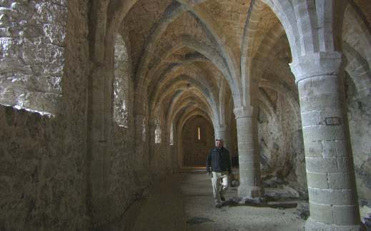
Richard Bangs explores the dungeon of Chateau Chillon on Lake Geneva, Switzerland, in his latest Adventures with Purpose special from American Public Television. In Geneva & the Matterhorn—Quest for the Water Castle, Bangs seeks to discover how this alpine region has resisted temptation to bleed its most precious resource—water. His adventures take him to Lake Geneva with stops in Geneva, Lausanne, Vevey and Nyon along the lake-shore. Then Richard heads up the Rhone River Valley exploring the Val D’ Herens, Lukerbad, the Valais, Zermatt and the Matterhorn. Finally Bangs climbs up to glaciers that are the wellspring of the great river high in the pristine Uri Alps. Adventures with Purpose, a multiple award-winning series, is produced by Small World Productions of Seattle and co-produced by KCTS/Seattle and Richard Bangs Productions of Marina del Rey, California. The series is distributed in HD and SD formats to hundreds of public television stations across the US by APT Exchange.

Photos and press kit documents may be downloaded from www.AdventuresWithPurpose.TV




